QuArk Map Editor for Mahatta Tutorial

Quark Prefabs

Prefabs is the abbreviation of pre-fabricate (put together, construct). When making maps, you usually want to have pre-generated objects to use so that you don’t have to make them over and over each time you start a new map. These are stuff like furniture (chair, table), pillars, trees and etc. So all you have to do is select from the list of pre-fabricate geometry and add it to the map.

Let’s start with a map opened in Quark.

Construct a group of geometry under a new group folder; this can be anything, like a chair:

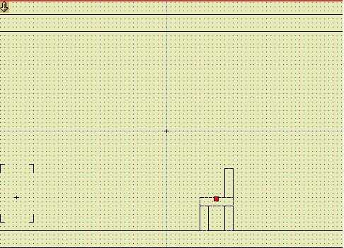
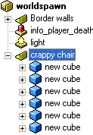

Press ‘Insert’ or click on ‘Toolboxes’ on the menu, and click ‘New map items…’. This will open a new window:

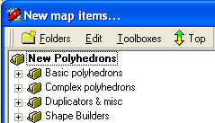

Under that menu, click on ‘Folders’ and then click on ‘New main folder…’. This will pop up another window ‘New Toolbox Folder…’.

Select ‘In a new Add-on’ and click ‘OK’.

Type in a name for the new file (ex: furniture) and click ‘Save’. This will add a folder called ‘New Folder’ under ‘New map items…’. Scroll down till you see that folder:

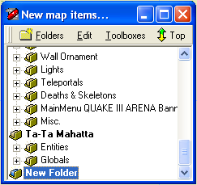

Click on the highlighted ‘New Folder’ once and rename it to however you want, preferably the same name as the file itself (ex: furniture).

Now back to the map editor, highlight the group folder you created (ex: crappy chair as shown above). Copy this folder by pressing ‘Ctrl+C’. Or right click, under ‘Edit’, click ‘Copy’:
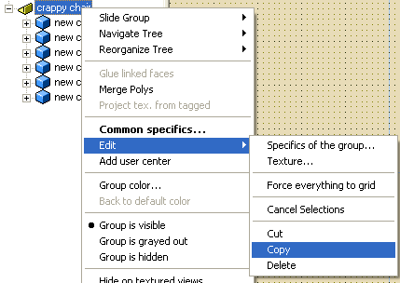

Go back to the menu: ‘New map items…’ (Toolboxes->New Map Item). With the folder you created highlighted, paste the group folder by pressing ‘Ctrl+V’ or click on ‘Edit’ and click on ‘Paste’. You should be able to see the new group folder as a sub folder:
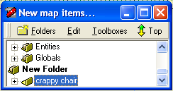

Double clicking on the new group folder will add it to the map.

To add other prefabs: In ‘New map items…’, click on ‘Folders’ then click on ‘Add-ons…’. This will pop up ‘Game Configuration’ menu. From here, you can remove and add map items for Quark editor to use. You can for instance select your newly created add-on and remove it from Quark.

To add a new add-on, simply click on ‘add’ and select from the list of add-ons to add. All of the custom add-ons are stored in the main Quark folder (eg: C:\QuArK\quark-win32-6.4.0alpha3\), you will also see your newly created add-on there once you save it.

